**Weekly Update**

[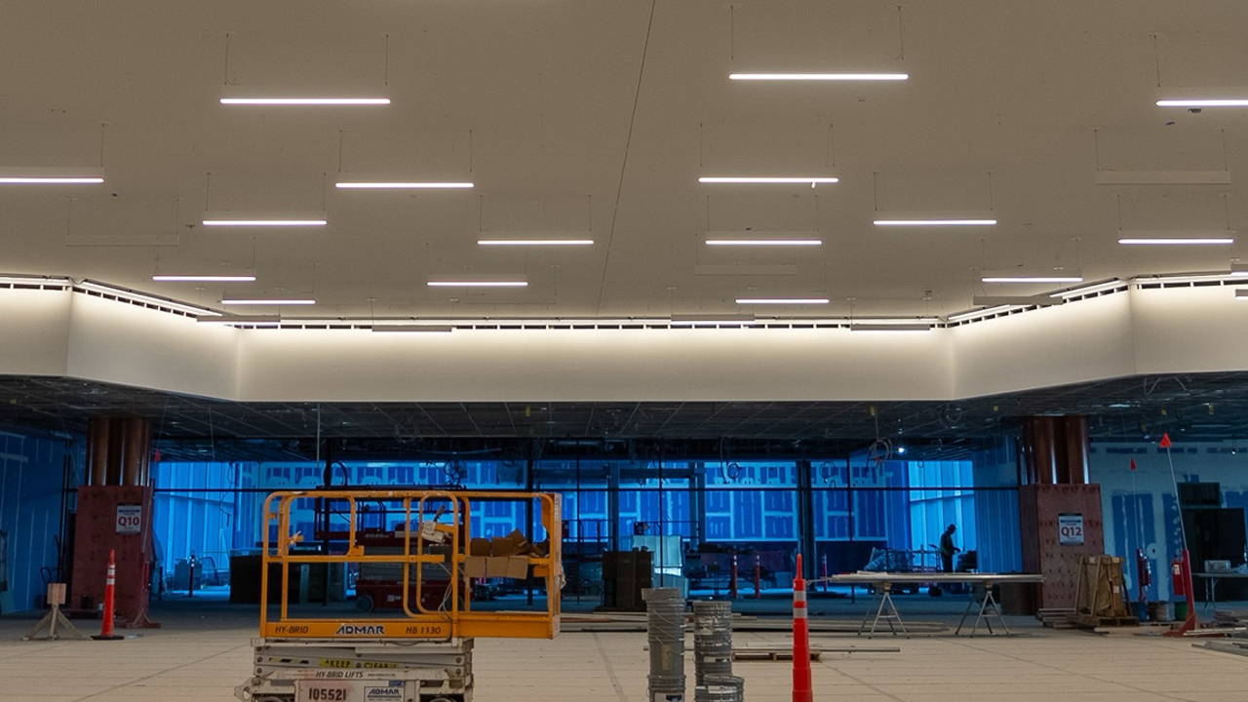](https://pittransformed.com/wp-content/uploads/Arrivals-Ceiling-Feb.-3-2025.png)

**Arrivals Hall in the Spotlight – February 3, 2025**

Construction in the arrivals hall of our new airport made significant strides this past week with the commencement of ceiling panel and lighting installations. Every design element, from the color palette to the lighting, has been thoughtfully selected to create a soothing atmosphere for passengers as they transition into the baggage claim area. We understand that travel can be stressful, and our goal is for the new PIT to provide a welcoming, relaxing environment where passengers feel at ease upon arrival.

This space was designed with the Pittsburgh community in mind as it serves as the heart of our meeter/greeter area, where family and friends can comfortably wait for loved ones. With a variety of concessions, cozy seating, and inviting outdoor spaces, this area offers a perfect setting for reconnecting after a journey.

**Wayfinding in New Parking Garage Begins**

[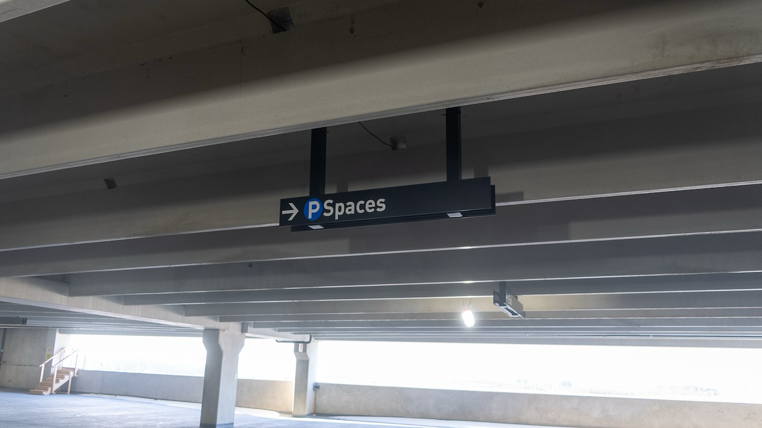](https://pittransformed.com/wp-content/uploads/MMC-Signage-Feb.-3-2025.png)

The installation of overhead signage has begun in our new parking garage, marking the first phase of an innovative wayfinding system designed to help drivers navigate the structure with ease and efficiency.

In addition to these signs, illuminated indicators will display real-time availability on each floor, streamlining the parking experience and reducing the time spent searching for a space.

We’re excited to open the new garage later this year, which will feature rental car services on the ground level and provide over 3,000 new parking spaces for the public.